Apress LightSwitch 2012 by Tim Leung – Chapter 13

Chapter 13 shows you how to create business type, theme, shell, screen template, and data source extensions.
Running the HelpDesk Application
To run the HelpDesk application, you’ll need to install the ApressExtensionCS or ApressExtensionVB VSIX files. This extension includes a custom shell, theme, and data source extension. The chapter explains these items in more detail. This VSIX file also includes the Add/Edit Screen Template extension.
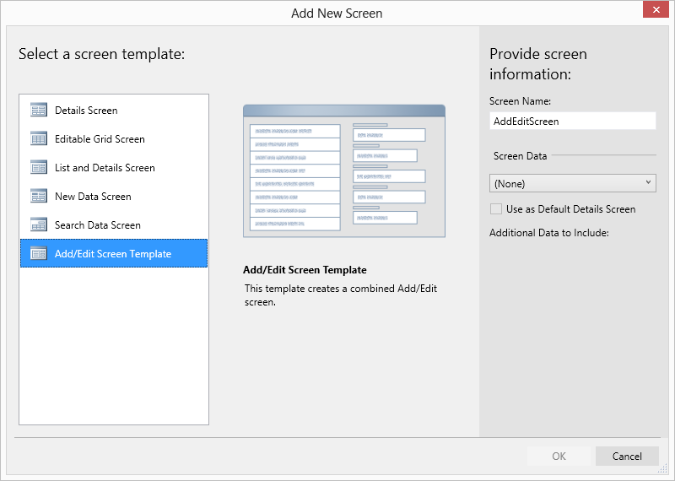

Extension Projects
To run the actual extension project,
- Install the LightSwitch Extensibility Toolkit. You’ll also need to install the Visual Studio SDK, and copy the Microsoft.LightSwitch.Toolkit.targets file into your %ProgramFiles%\MSBuild\Microsoft\VisualStudio\LightSwitch\v2.0 folder. You’ll find full instructions in the Extensibility Toolkit’s readme file.
- In your Client project, make sure that the reference to your ApressControlsVB or ApressControlsCS DLL file is correct.
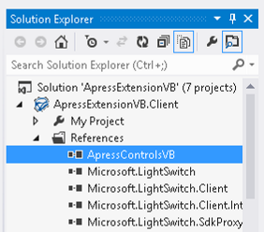
If the compiler complains about missing LightSwitch DLLs, you’ll find these in Visual Studio’s Private Assemblies folder.
On a 64 bit machine, the default location of this folder is here:
C:\Program Files (x86)\Microsoft Visual Studio 11.0\Common7\IDE\PrivateAssemblies
On a 32 bit machine, the default location of this folder is here:
C:\Program Files\Microsoft Visual Studio 11.0\Common7\IDE\PrivateAssemblies

Tim Leung

